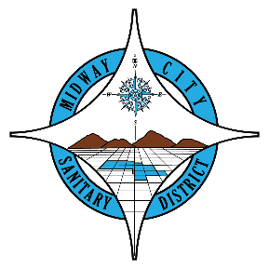
FOR IMMEDIATE RELEASE
October 30, 2025
Contact: Ashley Davies
Director of Servies & Program Development
Midway City Sanitary District
14451 Cedarwood Street
Westminster, CA 92683

OC Taxpayers Association Rose Award Presented to Midway City Sanitary District

Midway City Sanitary District (MCSD) has been awarded the Rose Award by the Orange County Taxpayers Association (OC Tax) in recognition of its outstanding commitment to fiscal responsibility, transparency, and excellence in public service.

“We’re truly honored to receive this award,” said, Board President Sergio Contreras. “It’s a reflection of our entire team’s hard work and dedication to serving our community every day. We take pride in making sure our residents can count on reliable, affordable, and transparent services.”

The OC Tax Rose Award is presented annually to public agencies that exemplify best practices in governance, efficient use of taxpayer dollars, and commitment to open and responsible administration. The honor reaffirms MCSD’s role as a leader in transparency and fiscal accountability among local public agencies. It follow the District’s recent recognition by the Special District Leadership Foundation for achieving the District Transparency Certificate of Excellence, further showcasing its ongoing commitment to open and responsible governance.

About Midway City Sanitary District: Established in 1939, the Midway City Sanitary District (MCSD) is an independent special district dedicated to providing essential solid waste and wastewater collection services to approximately 100,000 residents in the City of Westminster and the unincorporated community of Midway City in Orange County, California. MCSD is the only agency in Orange County that still provides residential curbside solid waste collection services directly with in-house staff, ensuring exceptional service with greater accountability and community connection, while maintaining one of the lowest service rates in the County.

For the latest news, resources, and updates, visit www.midwaycitysanitaryca.gov and follow MCSD on Facebook and Instagram. To contact our staff, email info@midwaycitysanitaryca.gov or call (714) 893-3553.
