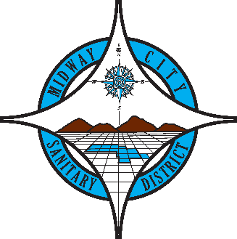
FOR IMMEDIATE RELEASE
May 20, 2026
Contact: Ashley Davies
Director of Servies & Program Development
Midway City Sanitary District
14451 Cedarwood Street
Westminster, CA 92683

Midway City Sanitary District Receives 2025 SDRMA Innovation Award for Proactive Safety Initiative

Westminster, CA – Midway City Sanitary District (MCSD) has been named the recipient of the 2025 Innovation Award in the Large Member Category by the Special District Risk Management Authority (SDRMA), recognizing the District’s forward-thinking approach to improving safety and reducing operational risk.

The SDRMA Innovation Award honors member agencies that develop and implement creative solutions to address safety challenges and enhance risk management practices. MCSD was selected by the SDRMA Board of Directors for its innovative response to a growing hazard in the solid waste industry: fires caused by improperly disposed batteries in residential trash carts.

To combat this issue – commonly knows as “hot loads,” where compacted batteries ignite inside collection trucks – MCSD invested in the installation of Amerex Automatic/Manuel Fire Suppression Systems across its solid waste fleet. These systems provide both automatic detection and suppression of fires, as well as manual activation by operators for immediate response.

“This recognition reflects our commitment to protecting our employees, our community, and our infrastructure,” said Board President, Chi Charlie Nguyen. “By proactively addressing a serious safety risk, we are not only improving working conditions for our drivers but also ensuring reliable service for the residents we serve.”

The implementation included a comprehensive fleet assessment, operator training, and integration of the system into existing maintenance and safety protocols. Since deployment, the District has significantly reduced the risk of catastrophic vehicle fires, improved emergency response capabilities, and strengthened its overall risk profile.

The key outcomes of this initiative include enhanced employee safety, reduced property damage and liability exposure, increased operational reliability, and lower risk of insurance claims and associated costs. MCSD was formally recognized at SDRMA’s Education Day on March 18, 2026 in Sacramento, California.

About Midway City Sanitary District:
Midway City Sanitary District provides essential solid waste collection and sewer services to residents in Westminster and Midway City, California. The District is committed to delivering reliable, efficient, and safe services while protecting public health and the environment. For the latest news, resources, and updates, visit www.midwaycitysanitaryca.gov and follow MCSD on Facebook and Instagram. To contact our staff, email info@midwaycitysanitaryca.gov or call (714) 893-3553.

